***ISABELLA VENTO : FINAL DOCUMENT FOR TEACHING AS ART 2019***

***REFLECTION & FEEDBACK***

*From teaching to content and feedback*

It is difficult to maintain the confidence and demeanor that ‘you know what you’re doing’ when what you are attempting to involve participants in is an unpredictable process. Additionally, this lack of confidence and certitude could lead to giving participants ‘too many options’ (for discussion, exercise/activity execution) and not arriving to the results that were intended, which is what happened in the first iteration of the ‘Anti-Drift Lab’. *The Map of the Encounter of Encounters* did not become and anchor or a vehicle for the ‘temporary assemblage of material identities’ that I had hoped for*.*

People arriving late is a reality and hump that can perturb the balance and smooth running of the workshop. Does one aid those who have not arrived on time and risk not attending to those who have? Or must one gain the dexterity to compensate for late-comers and allow them to smoothly join the bandwagon?

People do not read e-mails. This is not a fault - rather a result of the hyper-productive demands of a late capitalist society. Either one gains the magic capability of placing things on an inbox canvas such that each word attracts the attention of a receiver and the instructions exude minute clarity OR one must allow themselves to carry out the workshop within the parameters of the time it is scheduled at, [ simultaneously providing the majority of materials. ] I still believe I did the best I could to experiment with the material I wanted to cover & 7 out of the 9 participants in the workshop did, indeed, complete the requested ‘anti-drift.’

I was pleasantly surprised to the responses in my feedback form for this question:

|  |
| --- |
| ***What did you interpret as the learning objectives of the workshop (including both the walk & the meeting)? 5 responses***  A) To exist in a space outside of rushing to be somewhere or acting as you are "supposed to" - to walk in non-right angles, explore, think about things that are there and why are they are there, and who maintains them  B) (Collective) observing the world with intention, better understanding city infrastructure (through speculation & discussion), establishing vocabulary (assemblage, maintenance)  C) opening our senses to the reality / materiality / physicality of our city environment. changing the pace, interrupting, slowing down.  D) to drift, and later to anti-drift, as a contemplative and awareness practice  E) I interpreted it as a kind of group close-reading of a slice of urban area |

All of the words highlighted are certainly what I intended for the workshop to be and I think what largely contributed to this was the field guide as opposed to the meeting. I did feel that due to some of the challenges mentioned above, I was not able to stay true to a structure that I had planned to follow those fifty minutes (Post-drift ease-in, mind map in pairs/mapping together, discussion & context). Having directly spoken to a couple of the participants, I got mixed feedback from them: Luming expressed that he liked the open-endedness of the discussion and was interested in seeing where that would take us yet Sofia said that she felt the meeting was not structured enough and did not have a clear idea of what we were doing/what it was for.

I am not sure if this has more to do with the way that I interpret and decide to perceive and, in turn, manifest looking at the world, but one of the most important aspects of this gig for me was to really emphasize the ‘emergence’ of discourse, debate, observation, associations etc. that would come from *the encounter* of these singular and individual *encounters with a space.*I was interested in creating a space that is the result of an experience of space and allows for a different perception of that very space. ***And diagrammatically document it.***

My own, personal relationship to the experience of ‘drifting’ is governed by my obsession with aspects of maintenance, repair, cleaning and care. I think this might have been the very reason the *Map the Encounter of Encounters* did not work; I was attempting to veer and guide it in my personal direction/interpretation/observation of urban space and elements. (This was also problematic during my dry-run of the workshop). If I had allowed this space that I am mentioning to genuinely materialise I would have occupied myself in creating better tools to create this map in accordance to the emergent conversation. In fact this came across in some of the feedback comments from lack of structure to desires for other subject matter :

|  |
| --- |
| ***Do you wish there was any knowledge or information that you acquired that was not part of the material covered? What did you feel was missing? 5 responses***  A) Not necessarily. I liked how facts about things that people chose were revealed in the workshop  B) This is hard to say! It felt cohesive. My only thought is it might have been helpful to have 1-2 readings for context beforehand (but maybe the intention was to avoid this kind of bias?).  C) an acknowledgement of life forms and their flow in the space  D) I think I didn't need an historical background for drifting, but I think it would have been useful for the anti-drifting part, to try to connect everything I guess, or give it a context  E) i think i would have liked to know more about the justification for the material choices of the manufactured architectural elements of the area |

|  |
| --- |
| ***Do you have any other comments? suggestions? desires? criticisms? questions? (don't hesitate to be brutal)***  A)I enjoyed it! It wasn't hitting me over the head with your point or info but it definitely changed the way I think about public space and things in public spaces. I will pay more attention to aspects of public space that were in the background for me before and have now been brought more into the foreground.  B)I found this to be extremely fun.  C) why "anti drift"?  D) I think that the workshop could have had a more narrative structure, the drifting could have had a more clear direction/s  E) maybe more prompts around the sound of the area |

I underestimated the difficulty of what I was doing, and have reconciled by doing some research on hand - drawn mapping and diagrammatic thinking to include this as part of the context in a second iteration and in a reconstructed syllabus. I am intuiting that it takes an incredible amount of experience to cultivate the preparation for multiple outcomes of a discussion or activity. I was not ready.

As noted, the title of the workshop was problematic. I still believe in my contextualisation of this, so instead of naming it differently I think I should aim to allow participants to understand why I am calling it that; this does call for a brief explanation of what ‘drifting’ is and perhaps it would provide the right abstract landscape to play in. I think I should have provided this conceptual context as opposed to talking about the history of Astor Place towards the end of the workshop.

Here is some other feedback I received with highlighted bits that are informing how I go about a reconstructed syllabus for another experience:

|  |
| --- |
| ***Do you feel any different about the location that you visited? Or, do you feel any different about the elements that were taken a note of in the space? If yes, what parts of the workshop contributed to this shift? 5 responses***  A) Yes, I don't think I've ever spent that long on that triangle and I grew up in NYC and used to hang out just a block away from there a lot where there were more "obvious" things to do (not really) - also would take photos of random things I found on those walks, and reminded me of that state of mind of being totally open and agenda-less in one's environment.  B) Yes! The discussion around the walking space sign, learning about the Astor Place group, and connecting the public/private with the potential motivations of the Department of Transportation was really thought provoking. It connected the space to potentially larger city trends. And history. It was also really interesting to learn what others picked out, observed, and learned as a result of their process--it was like revisiting the space from a new perspective.  C) the guided walk contributed, the guided / prompted sharing in small groups contributed  D) not really, I just noted things I hadn't notice before, but I don't feel different  E) i think i feel strange knowing how frequently i am near this area of protected pedestrianism that is still unfamiliar to me because my primary experience with it is a space to urgently rush through on my way to a late commitment |

|  |
| --- |
| ***Do you feel that this is a worthy and valuable way to 'collect data'? Why or why not?***  A) Yes - I think it could be cool if it was all added to like a map or database that could be collaborative and added to over time or something like this, if you were interested in doing that -- the analog map is like that and maybe more fun than the internet anyway. But some correlation from the analog map to a database or something could be cool if it is continued or to make it collaborative somehow in long term  B) Sorry I can't articulate this well, but there's something to the accelerating "productivity" of society/societies and accelerating environmental destruction, and in general I think it's valuable to consider ways we might slow down. I also think it's valuable to reconsider what kind of data is easy collectible, quantifiable, what we're capturing this way, and why.  Especially coming from a program where environmental sensing is very valued or something, we should be considering what we are measuring, why, whether we're capturing the information we want directly or indirectly--this personal kind of observing and capturing provided a humanizing aspect that I appreciated.  C) yes - low tech, subjective, slow  D) I think it is, but at the workshop I didn't really saw that coming to fruition. I think that interesting things can come out off drifting, and Ive personally have used that technique to develop artistic projects, but I think the benefits or gain that come out of drifting wasn't clear at the workshop  E) yes, i think it is as "good" as any other method of data collection |

***DOCUMENTATION from first worskhop run:***

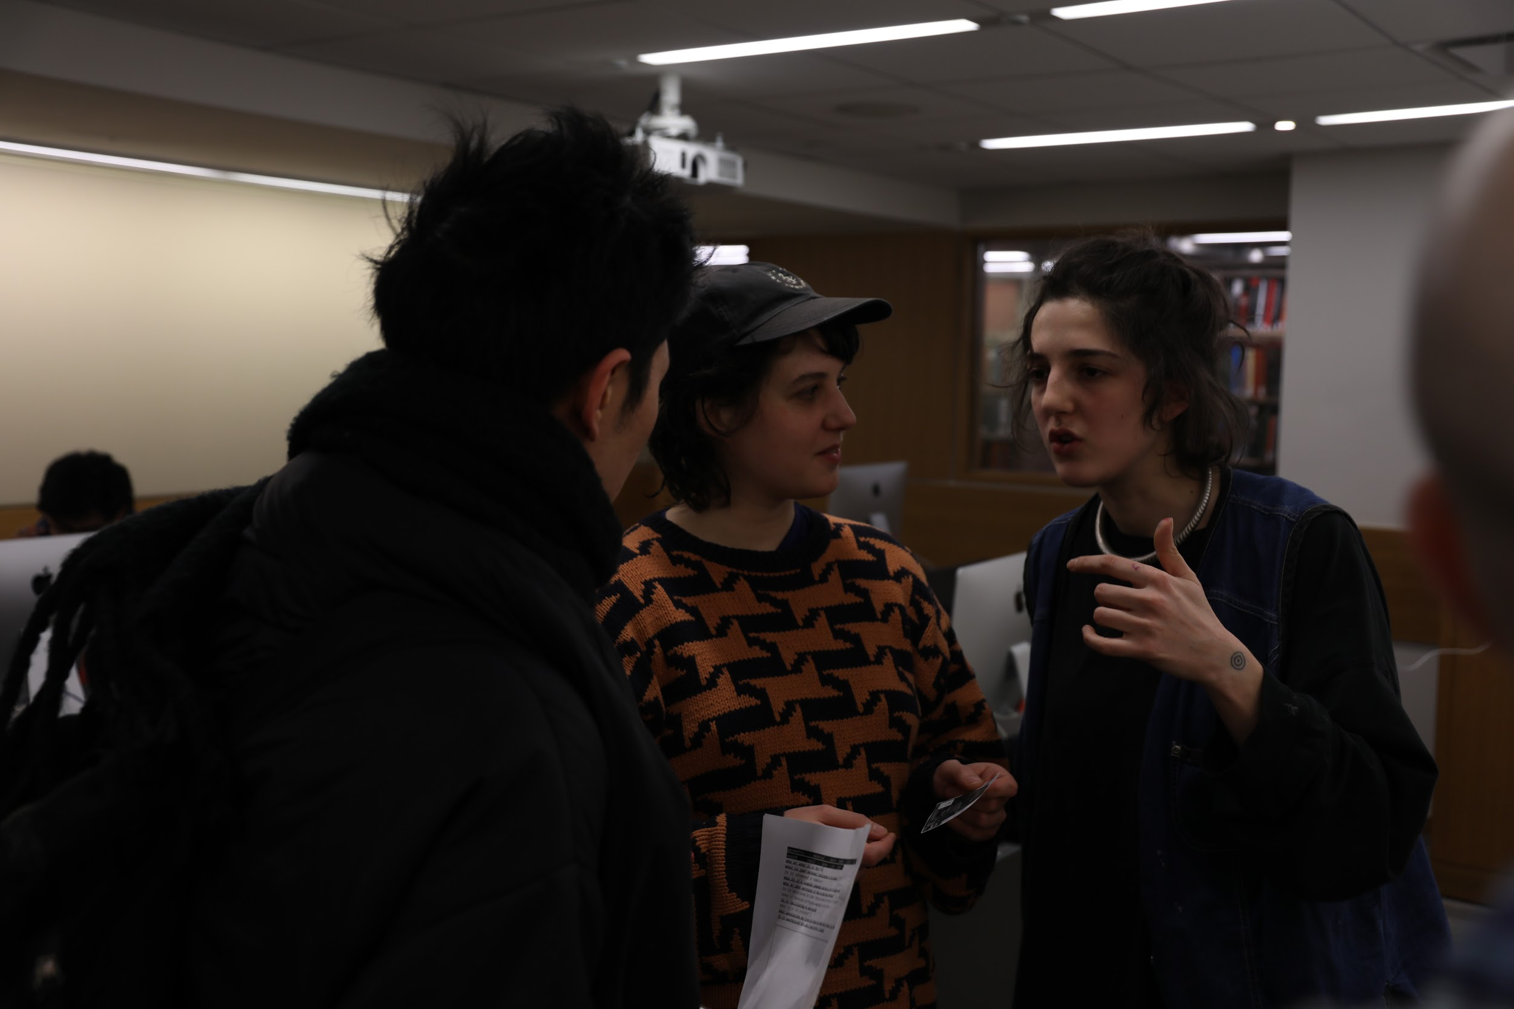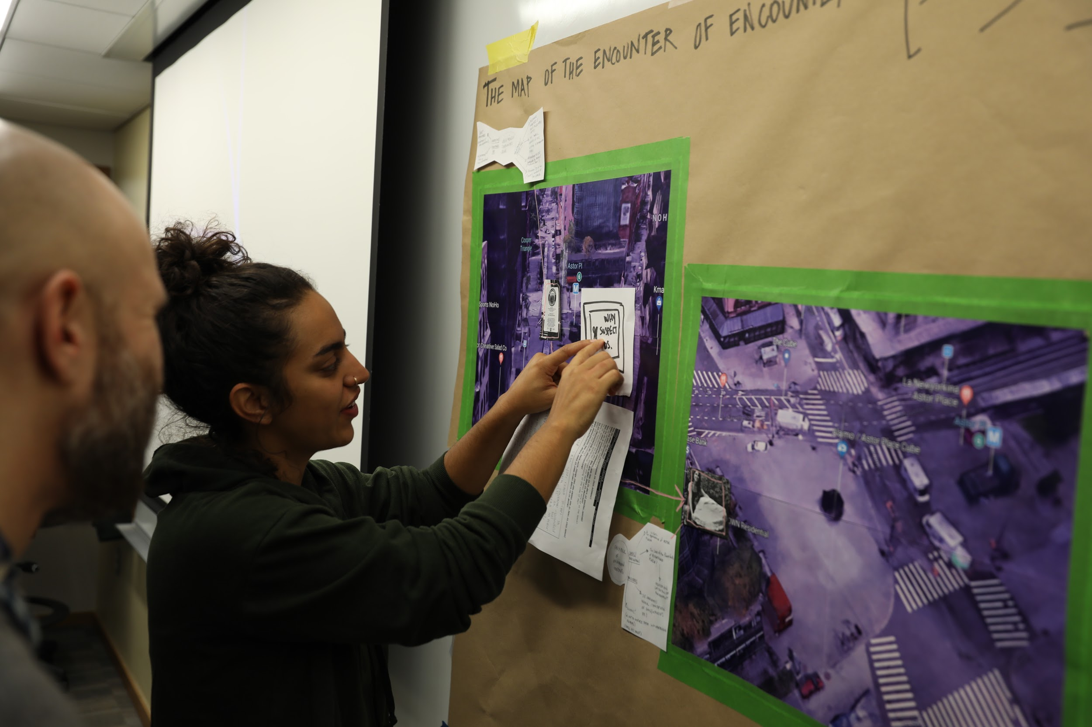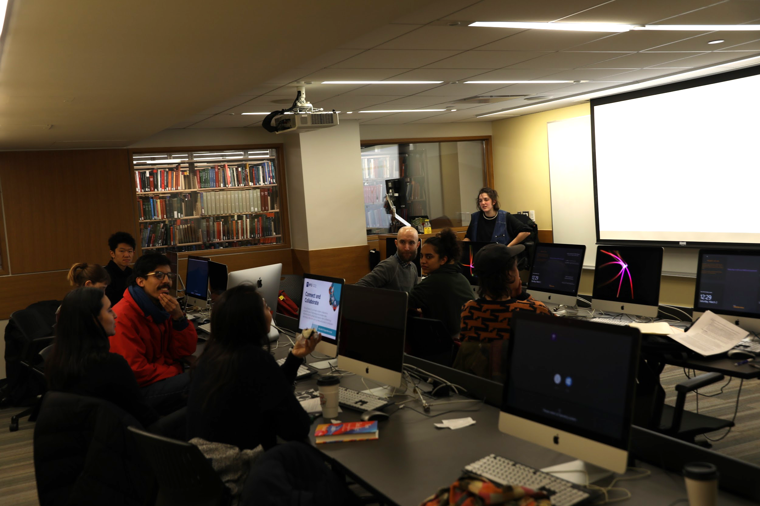

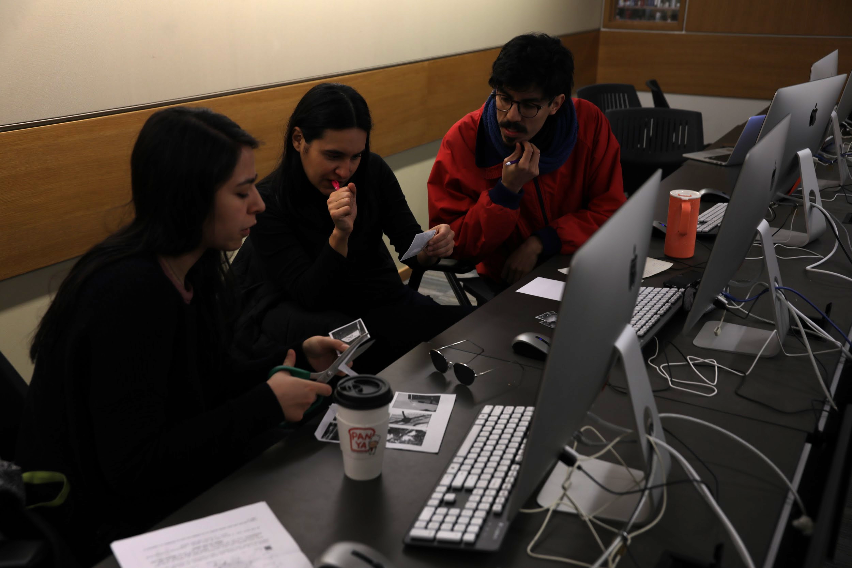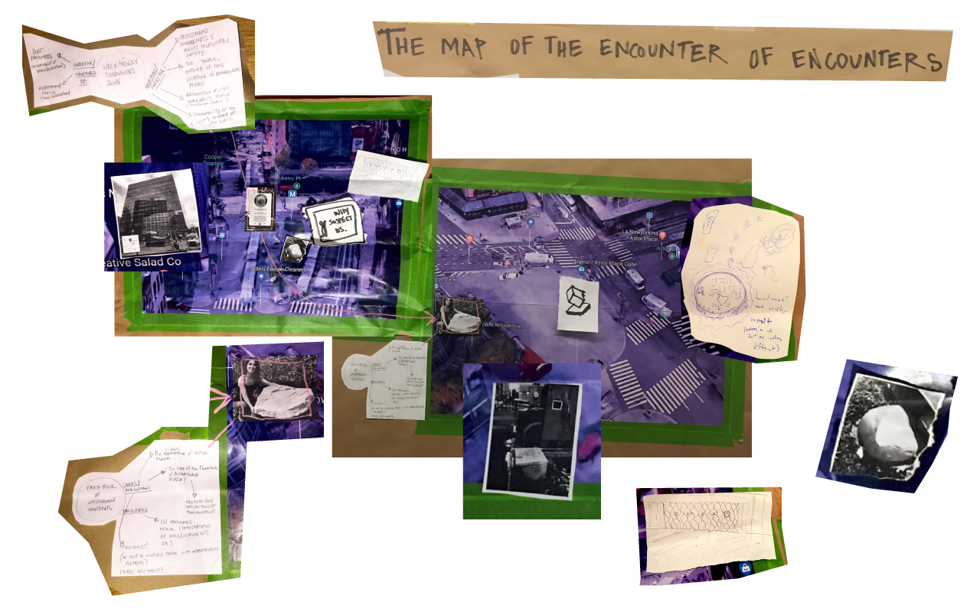

***RE-VISITED SYLLABUS***

*[in light of participant feedback, less time constraints and collective walk]*

***THE ANTI (or POST?)-DRIFT LAB***

**A WORKSHOP WITH ISA VENTO**

***Designed for 3 HOURS***

***# of participants: no more than 10***

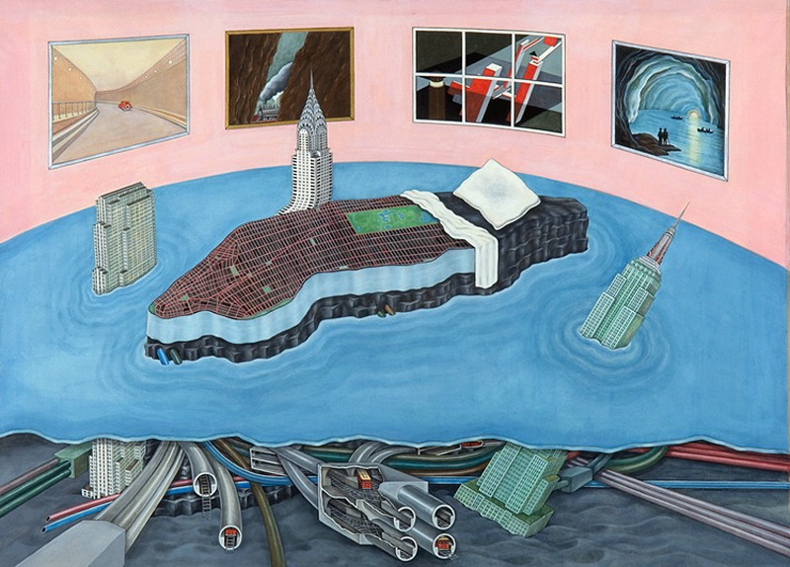

*Freud Unlimited, 1975, by Madelon Vriesendorp*

This workshop is an experiment of *collective deceleration.* Participants will engage in (and embody) a process of conscientious and slow data collection & processing. We will be visiting an urban location together, exploring it singularly & then come together to discuss and document our findings.

This workshop is called The Anti-Drift Lab because it is conceptually, physically and chronologically in opposition to the “dèrive”. Drifting is a practice that emerges from psychogeography, a mode of exploring urban environments relying on psychological impulse that was established in the later twentieth century. It implies that an individual must relinquish their agenda to navigate their walk; it implies aimless exploration of the many ‘ambiances’ of the city with a scope of resistance to the agenda the city may impose for its dwellers.

Participants of the anti-drift lab are given a field guide with instructions to absorb and pay attention to elements of their choosing within a given area and perimeter; they are to do so in one ‘ambiance.’ There is an aim in this activity, and it is similar to the derive in that it is ‘non-scientific research’, yet its results may have the potential to uncover essential truths that call for resistance *in the creation of alternative agendas of metaphorical and literal navigation of the city*, as opposed to the banishment of them.

In order for this conversation and documentation to flourish, participants will be given an introduction to diagrammatic thinking and examples of analog mapping. They will be prepared to interpret, dissect and re-assemble the subjectivities that arise from this temporary communion with others.

In the light of current times, becoming deeply acquainted, slowly, with the interactions between material things, non-human species and humans that occupy the city schema is a form of resistance towards the command of our navigation and co-existence. In turn, it allows us to formulate more informed agendas for our contribution to an equitable and resilient urban community.

*Objective*:  
  
Participants of the workshop are invited to be both learners and teachers of the situation. This is largely a guided experiment that involves attempting to identify the edges and nodes that make up the network of an urban location.

They will gain some tools for quick and dirty field research and take part in a discussion about the nature and emergence of this space. This will be done through the creation of a map of relations between their found elements; an abstracted data visualisation or assemblage of temporary connections.

*Materials*:

*For prep:*

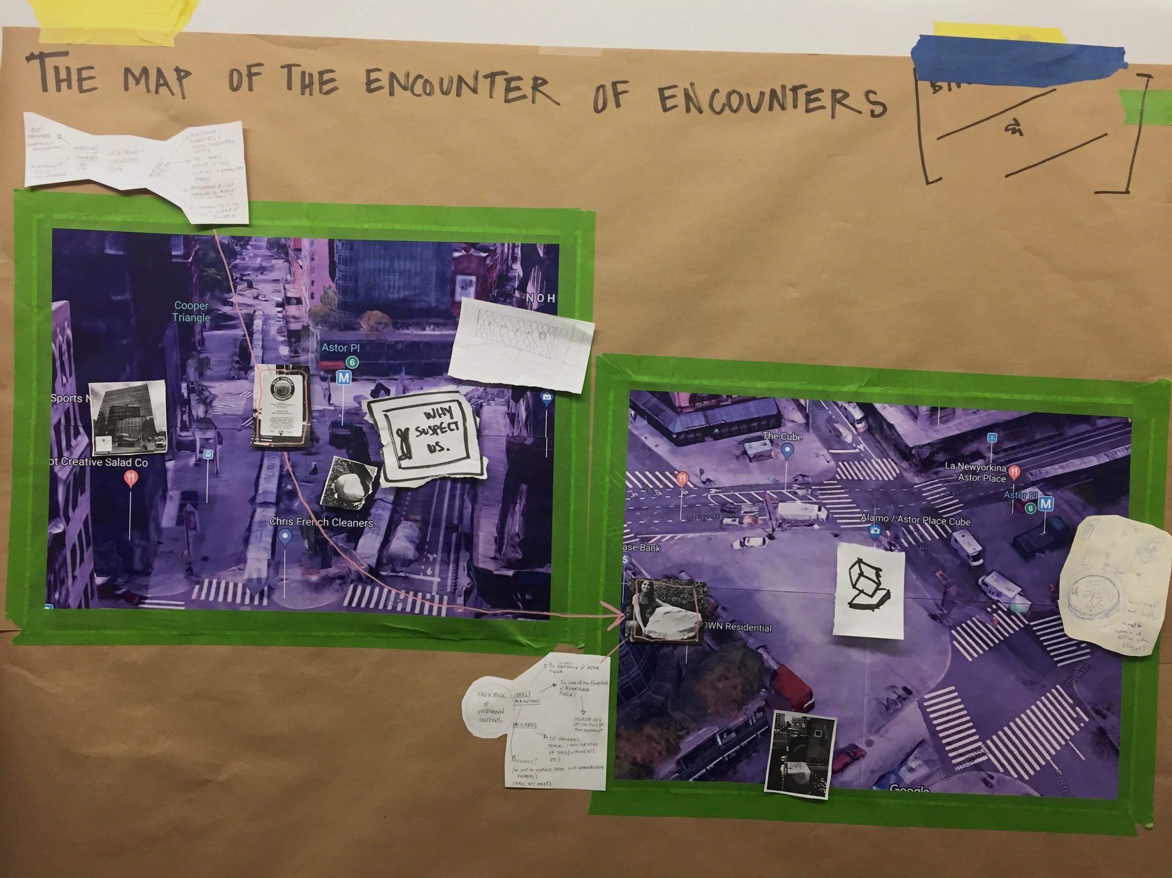

* Printed 3D vantage point maps screenshotted from google earth of given location in field guide ( make sure that all of location is in view ) In last workshop North and South-East vantage points sufficed.   
  **The size of each map was printed 4x letter-sized pages.
* Printer ( to print maps )
* Paper to paste maps on.
* Tape

For participants:

* Field guide
* Paper
* Markers (at least one per participant)
* Scissors
* Tape
* Ask that they be equipped with a fully charged phone (that has a camera on it), but this is not mandatory.

Budget:

|  |  |  |
| --- | --- | --- |
| Paper | For maps & for participants | 7 $$ |
| Craft Tape | X2 rolls for maps & participants | 12 $$ |
| Scissors | 5 pairs (enough to share) | 10 $$ |
| Acrylic Markers | 8-10 markers | 35 $$ |
| Printing facilities | Dependant upon accessability |  |

TOTAL: 64.00 $$

**PART I: The Walk**

***30-40 MIN***

**[**

**choose a given area for the excursion and edit a map such that the perimeter is clear & paste it into the** [**field guide**](https://docs.google.com/document/d/1q8DMZoHO9xN2AunBcDCer_Xg4B_m136rEu8Xnzz5DuY/edit)**:**

*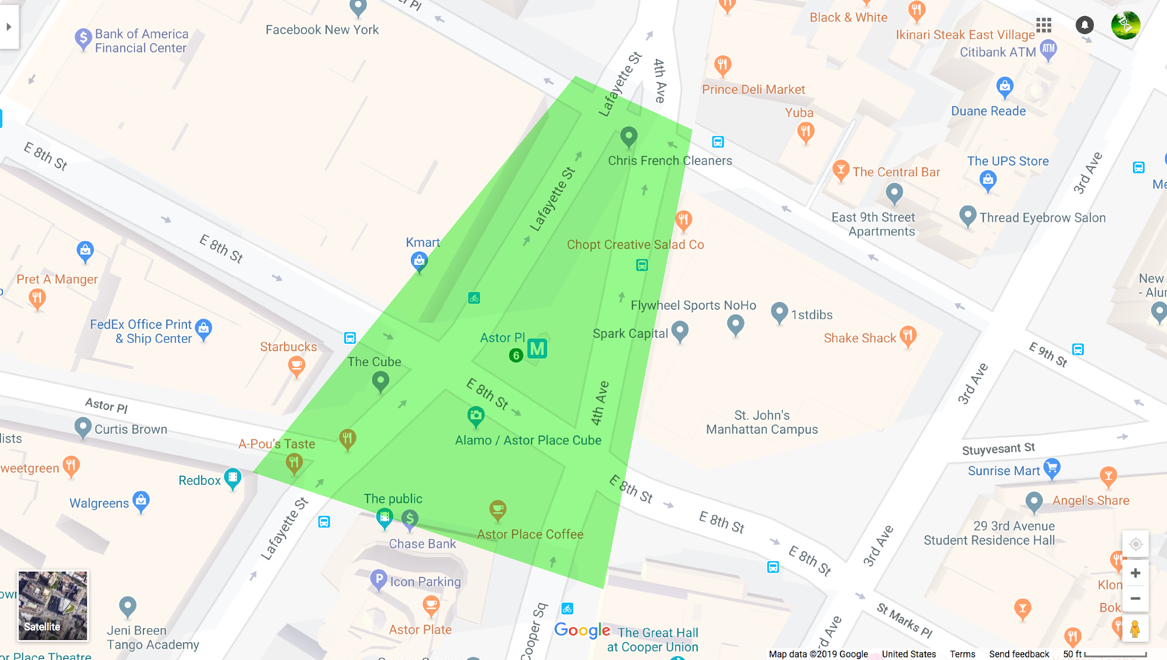****]***

1. Choose a meeting point for the participants in the given area.
2. Distribute the field guides and give them *30 minutes* for the walk.
3. Emphasize that it is best if they attempt to individually do the exercise.

***\*\* If the documentation that they make is an image that must be printed, have them send it to you & give some time to be able to print the images. **   
(this is instructed in the field guide)***  
  
 D) Meet back at meeting point & move to classroom.

*\*\*This might be a good time for a break in order for the printing to happen.*

**PART II**

**First Discussion and Context**

**40 minutes**

**\*\* READ THROUGH THIS SYLLABUS & GIVE AN OVERVIEW TO PARTICIPANTS OF WHAT WILL BE DONE.**

***A ) Easing into the classroom (15 minutes)***

** Everyone will have picked an element from the space visited (see field guide).   
** Make sure every participant has some physical documentation of the element chosen.

This is a time to become acquainted with everyone’s reasoning/context behind their findings. Each of these will be different and depending upon participants’ interpretations these may be very personal to their life or practice.

*\*\*If needed, take notes of general subject matters being brought to the table.*

[i.e. history, material extraction, social relations, infrastructure etc.]

→ Did you uncover things you hadn’t before?

→ How does this place feel different to you now?

→ What kind of details stood out to you most?

***B ) Pair Exercise & Finding Elements on the Map (15 minutes)***

*→ Pair people up following the discussion. Ask for them to make a mind map of the element they have chosen to treat in the space, using their notes from the field guide. This may take no longer than* ***5 minutes.***

*These are examples of what those mind maps could look like:*

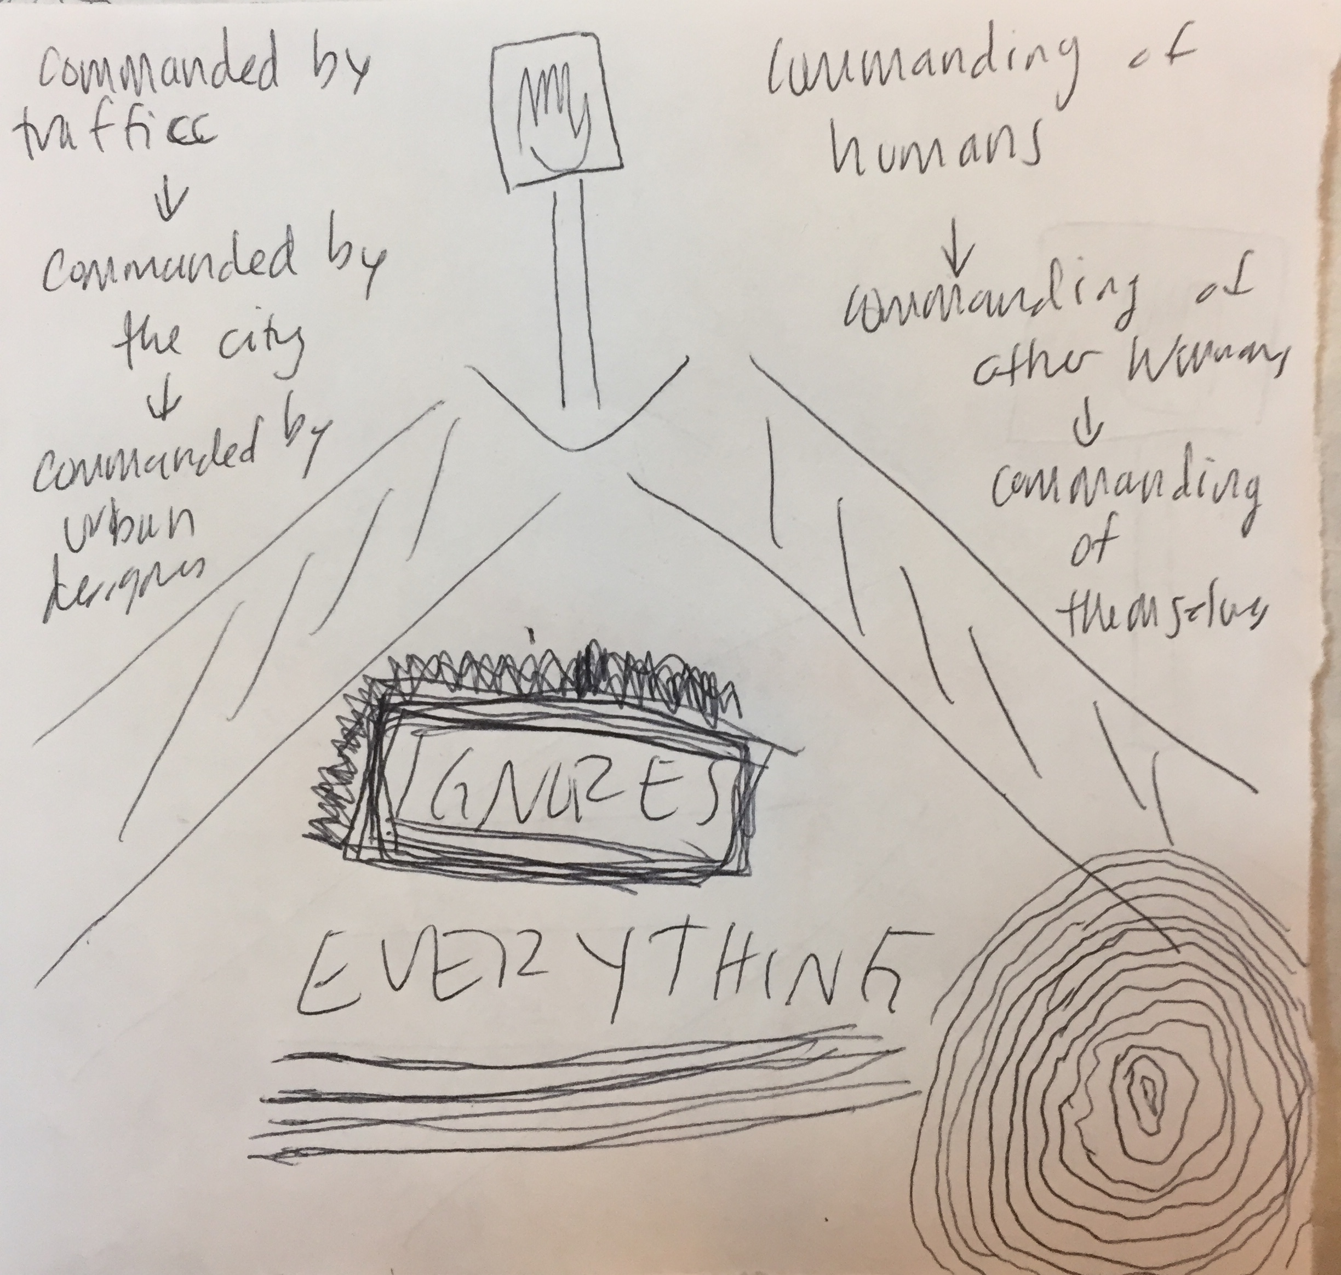 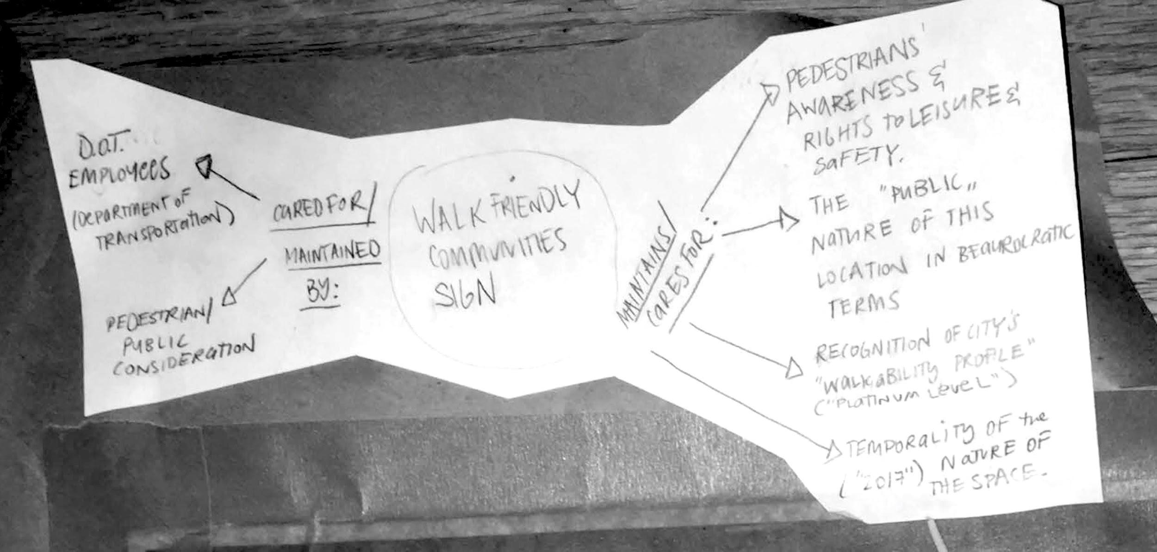

→ Ask participants to reflect on any kinds of associations that may exist between their partner’s element and theirs. (**5 minutes**)

*\*\*these questions could be based on the subject matter taken a note of before.*

Does one influence the the other ? How ?

Are there material overlaps ?  
 Are these for the public/private ? By the public ? etc.

→ Lastly, ask everyone to find the location of their element on the map & to paste it there.   
 **C ) *Context : Why is this an anti-drift? (10 minutes )***

→ Briefly introduce the when / how / why of the derive (5min.)

*Drifting is a practice that emerges from psychogeography, a mode of exploring urban environments relying on psychological impulse that was established in the later twentieth century. It implies that an individual must relinquish their agenda to navigate their walk; it implies aimless exploration of the many ‘ambiances’ of the city with a scope of resistance to the agenda the city may impose for its dwellers.*

References: [Theory of the Derive](https://www.cddc.vt.edu/sionline/si/theory.html)**,** [Drifting with The Situationist International](http://library.nothingness.org/articles/SI/en/display/238)

→ There is an aim in this activity, and it is similar to the derive in that it is ‘non-scientific research’, yet its results may have the potential to uncover essential truths that call for resistance *in the creation of alternative agendas of metaphorical and literal navigation of the city*, as opposed to the banishment of them.

**→ *The collection of these subjectivities aims to create a homogeneous assemblage of them - to create one artifact evocative of a consensus between every participants’ encounters...an encounter of encounters is the goal of the map.***

*→ INTRODUCE in this way the THE MAP OF THE ENCOUNTER OF THE ENCOUNTERS*

*→ Allow for discussion & questions (5min)*

**\*\*break\*\***

**PART IV:**

**Facilitation of Consensus :  
Diagrams, Maps and Associations**

**30 min.**

***A ) Overview of mind maps, diagrams & legends (10 min.)***

*“This widens the famous notion of Kleist that posits the creation of thought by/while speaking and the generation of knowledge with creating thought by/while drawing and observing, and thus unfolds lines or knots to form perceivable and notable spatial orders that not only accompany thought with illustrative graphics, but that actually show thought in the making, in which the universe itself is seen as a multiplicity of knotted and folded spaces that thought unfolds or explains on a perceivable plane.1” --*

*“The power of diagram-making could be described as the skill of change and transformation by reason, and may be “cartographic,”4 “topologic,”5 or diagrammatic. Diagrammatic thinking is, however, not so much about the concrete shapes and forms of the geometrical configuration of knowledge represented as about the dynamic of how the structures of connectivity and separation—together with attentive abstractions and the relation of points of connectivity (territorialization) and disconnection (deterritorialization) and reconnection (reterritorialization)—are performed, evolve, and show forces of change. “*

Both quotes from [**Diagrammatic Thinking**](http://monumenttotransformation.org/atlas-of-transformation/html/d/diagrammatic-thinking/diagrammatic-thinking-alexander-gerner.html)

**Works to talk about :

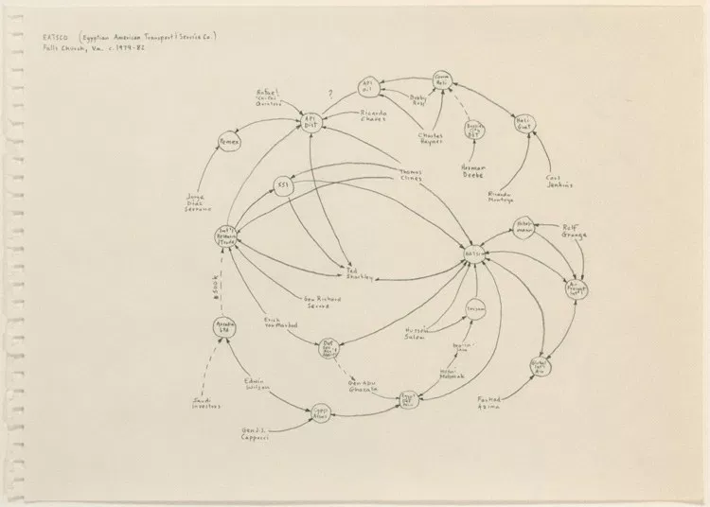

[**Mark Lombardi**](https://lombardinetworks.net/) **“EATSCO (Egyptian American Transport & Service Co.) Falls Church, Va., c.1979-82,**

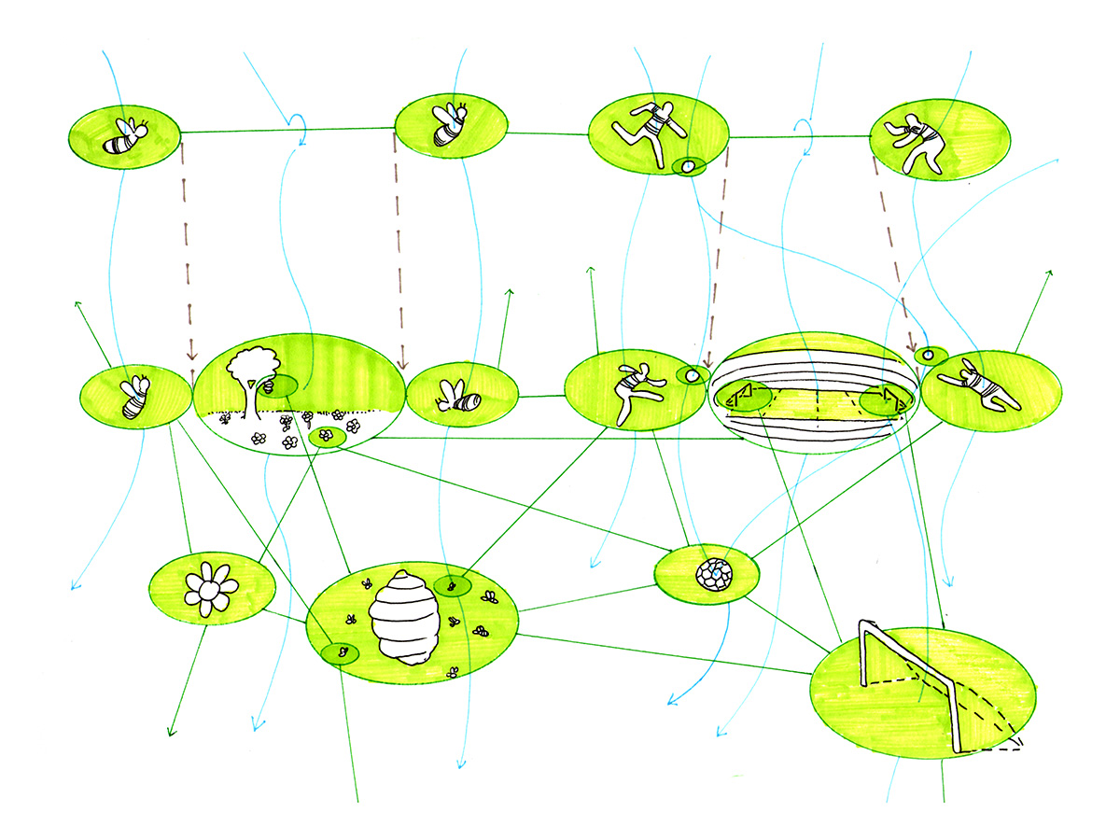

**Diagram from   
*1914: One or Several Wolves?* Series by** [**Happy Sleepy**](https://happysleepy.com/art/drawing-thousand-plateaus/)

***B) Discussion & creation of speculative legend***

*→ Adding associations to the map will need assistance; for this reason a legend will be created on the spot (this may be a color code legend or directional arrows of different kinds)...  
As the group discusses their findings, the legend will be drawn on the board by .*

*→ Ask participants about the associations they might have drawn when working in pairs*

*→ What similarities arose? Connections? Obstructions? Facilitations? Etc.*

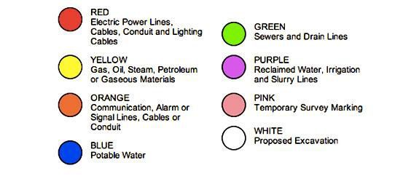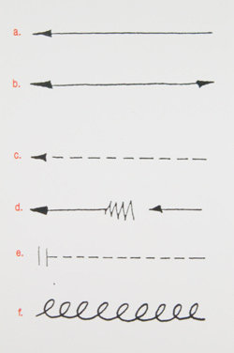

***A legend of one of Mark Lombardi’s pieces***

***Legend of Street Graffiti for cable***

***infrastructure***

*→ FILL IN the map of the encounter of encounters prompted by this legend together.*

*It could maybe look something like this: 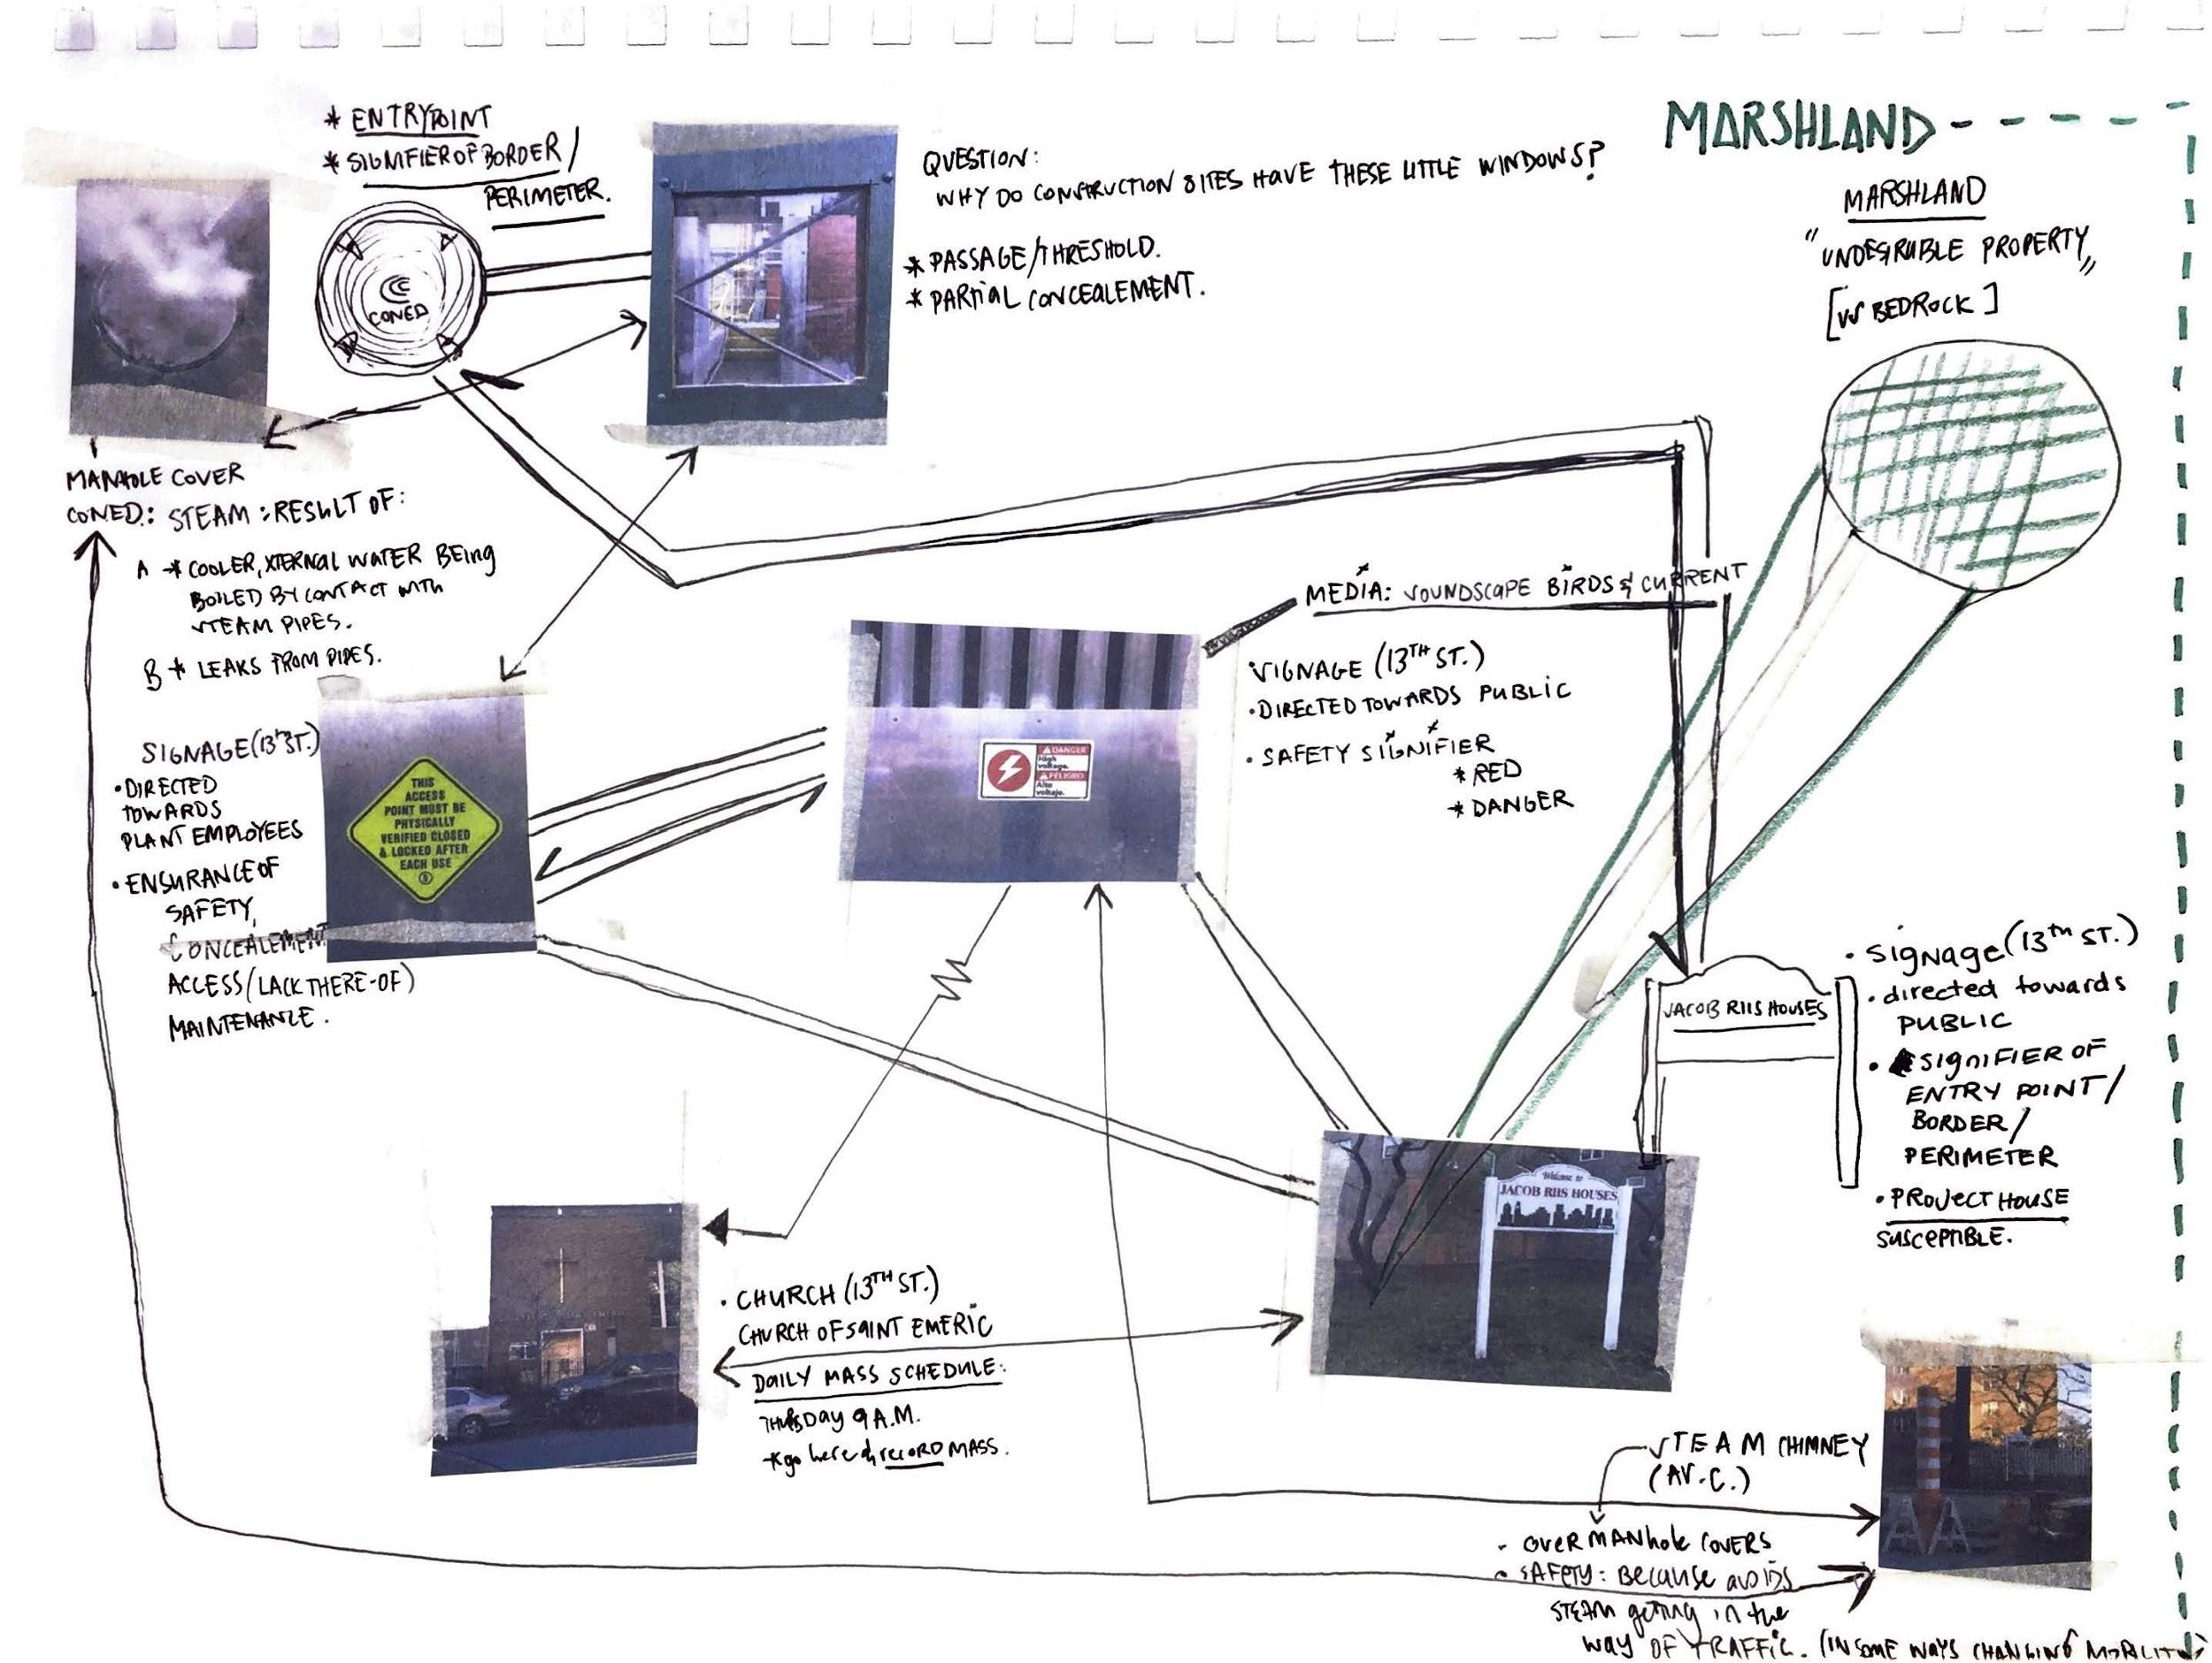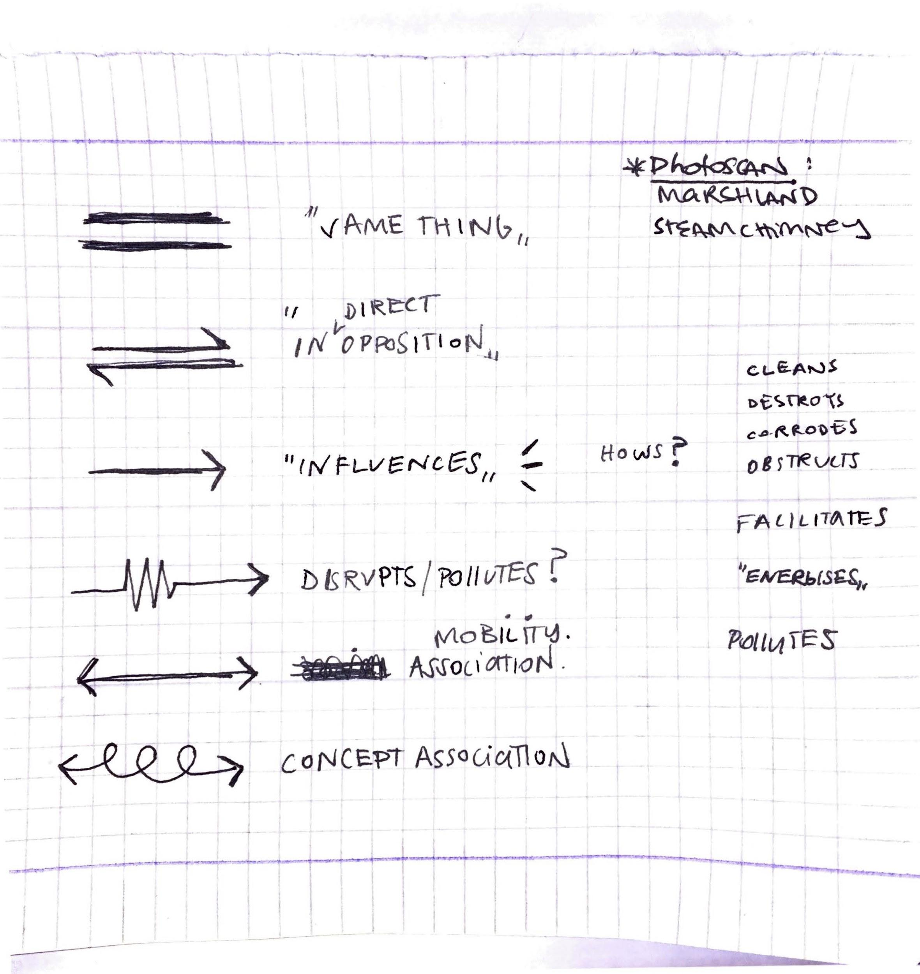*

*WRAP UP.*

*Other references:*

[***How to see infrastructure***](https://rhizome.org/editorial/2015/jul/2/how-see-infrastructure-guide-seven-billion-primate/)

[***Seeing Networks - Ingrid Burrington***](http://seeingnetworks.in/nyc/)

[**What does resilience mean ?**](https://thedistanceplanlexicon.org/RESILIENCE-RHETORIC)

[**Infrastructural Tourism**](https://placesjournal.org/article/infrastructural-tourism/)

[**Care & Maintenance**](https://placesjournal.org/article/maintenance-and-care/#ref_13)

[**User guidelines of Astor Place by the Village Alliance**](https://drive.google.com/drive/u/1/folders/1_M1qn_qt4R_596DsCrek8miEQzXOTg22)

Books:

*Underground* by David MaCauley

*The Life and Death of American Cities* by Jane Jacobs

*Ecology Without Nature* by Timothy Morton

*The Politics of Movement in an Age of Extremes* by Mimi Sheller